PART A

System does not converge due to mass imbalance of DMSO

Column 1 temperature profile

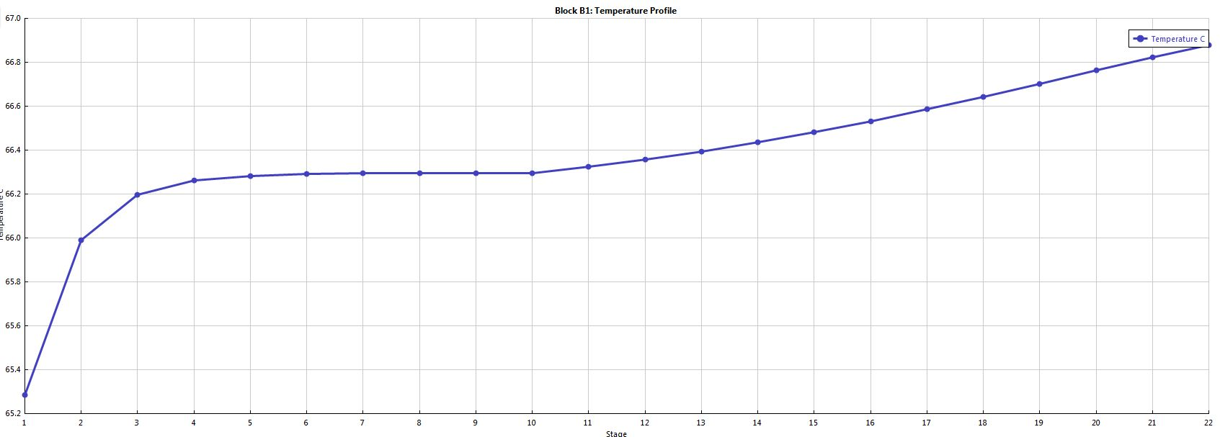

Column 1 composition profile

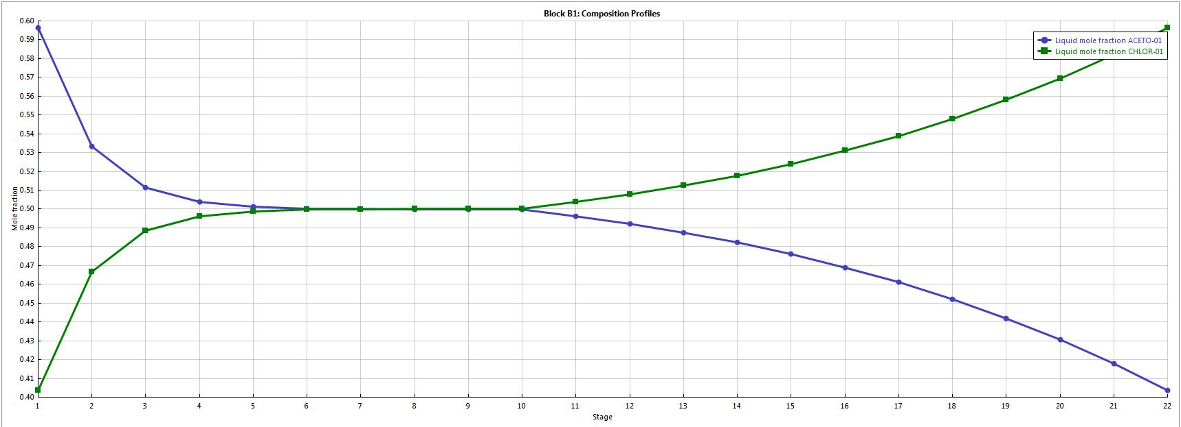

Heat duty of reboiler 201071.949 cal/sec

Heat duty of condenser -183981.402 cal/sec

Column 2 temperature profile

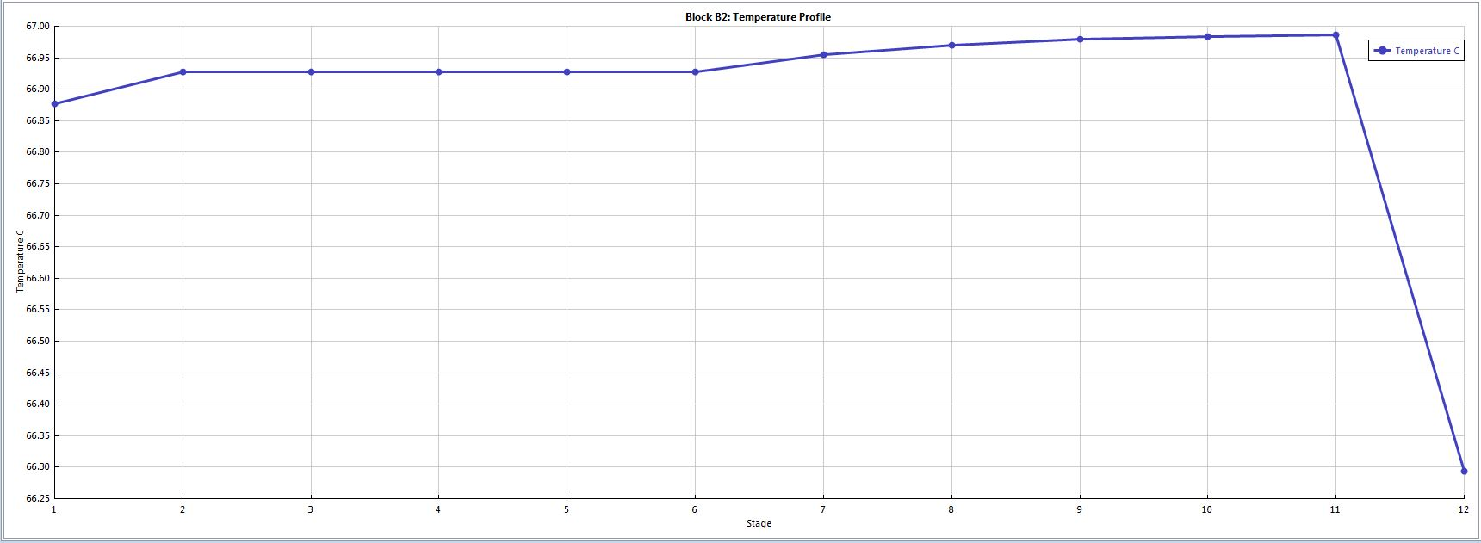

Column 2 composition profile

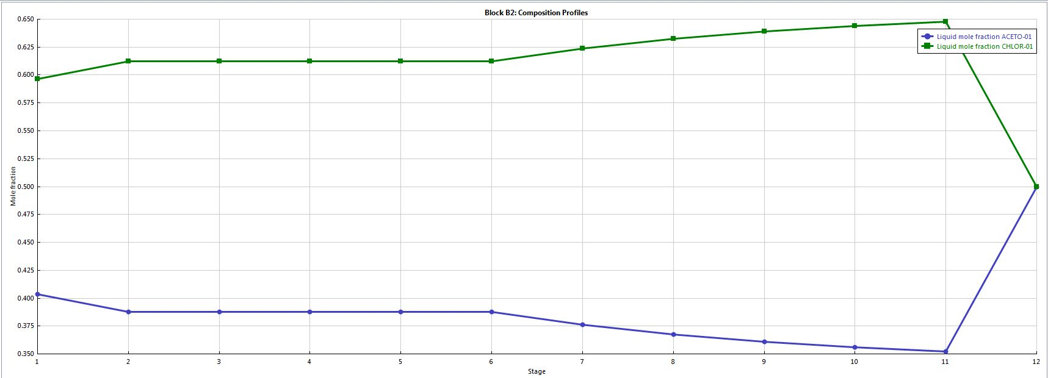

Heat duty of reboiler 166127.574 cal/sec

Heat duty of condenser -166127.575 cal/sec

PART B

Heat duty of exchanger: -249803.269 cal/sec

Column 1 temperature profile

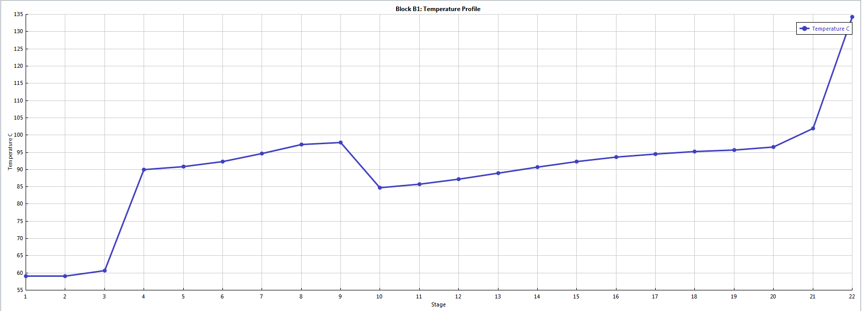

Column 1 composition profile

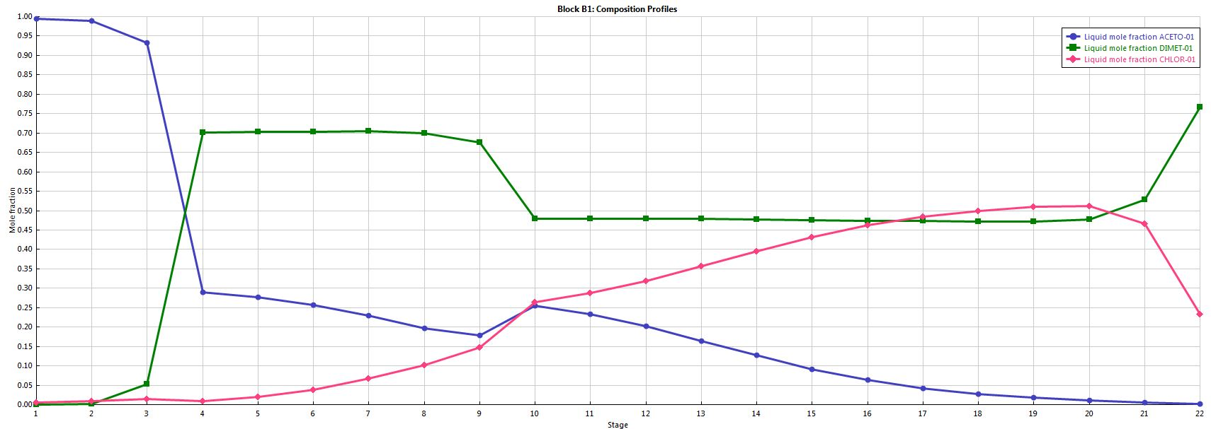

Heat duty of reboiler 358931.671 cal/sec

Heat duty of condenser -176404.784 cal/sec

Column 2 temperature profile

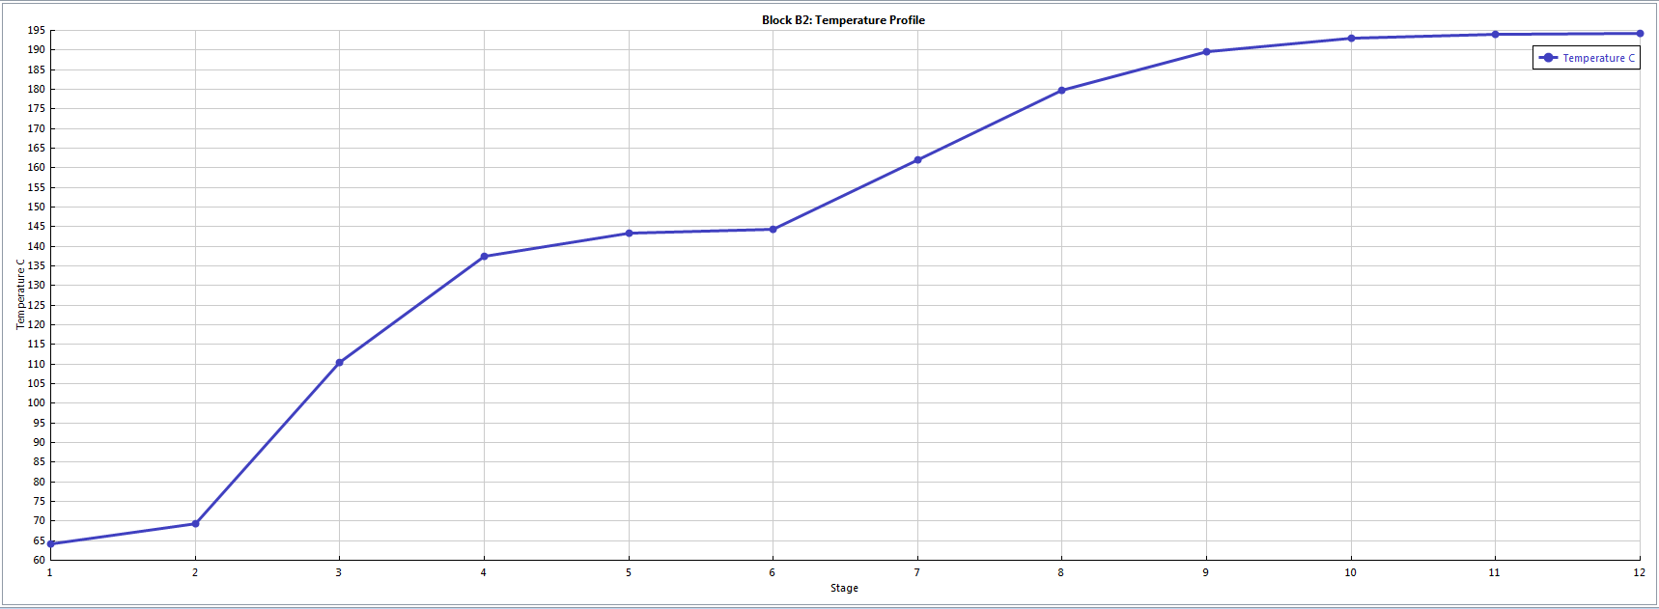

Column 2 composition profile

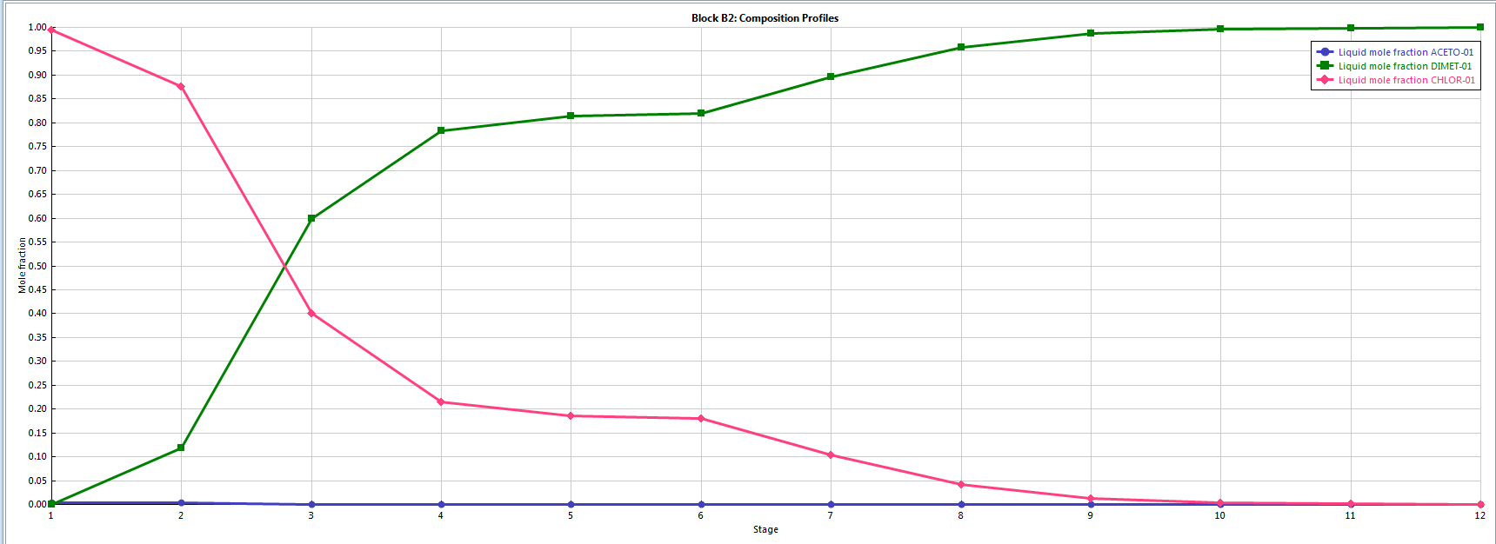

Heat duty of reboiler 251110.982 cal/sec

Heat duty of condenser -159892.328 cal/sec

PART C

Heat duty of exchanger: -249803.269 cal/sec

Column 1 temperature profile

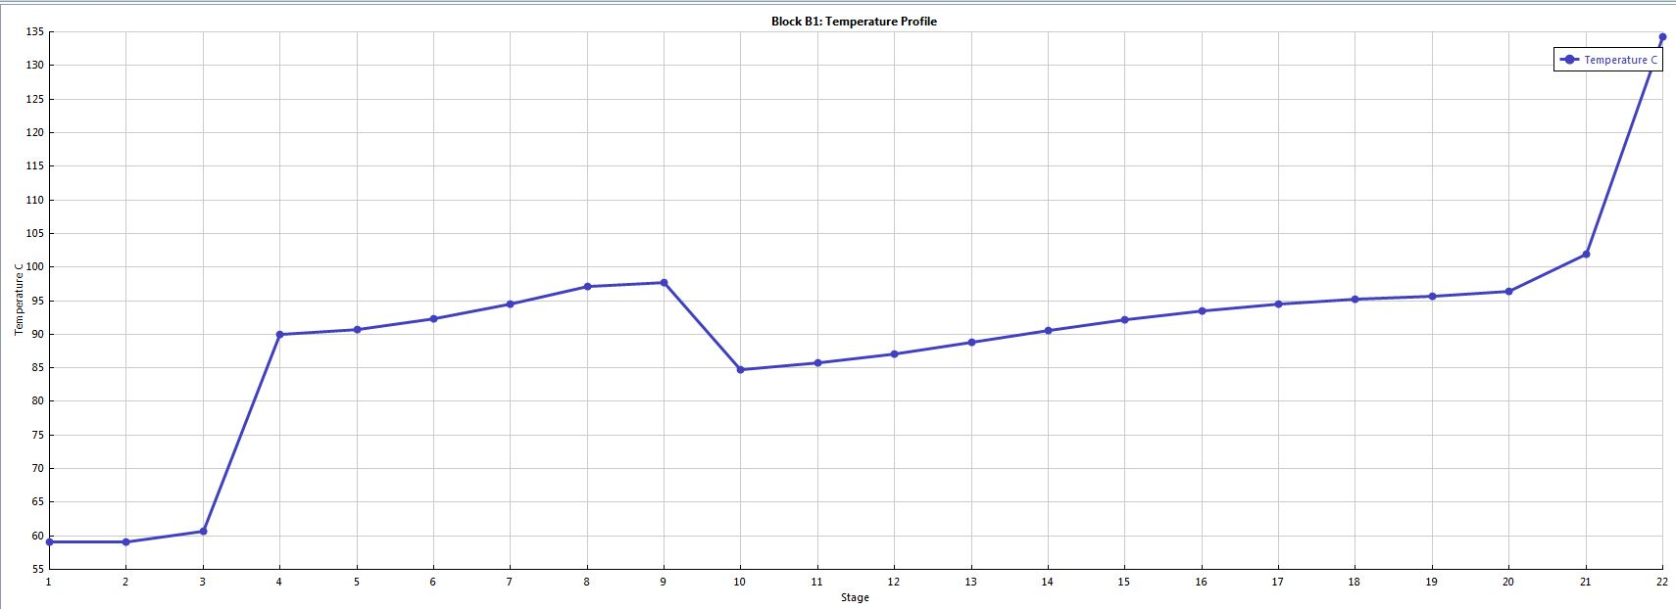

Column 1 composition profile



Heat duty of reboiler 358938.865 cal/sec

Heat duty of condenser -176410.88 cal/sec

Column 2 temperature profile

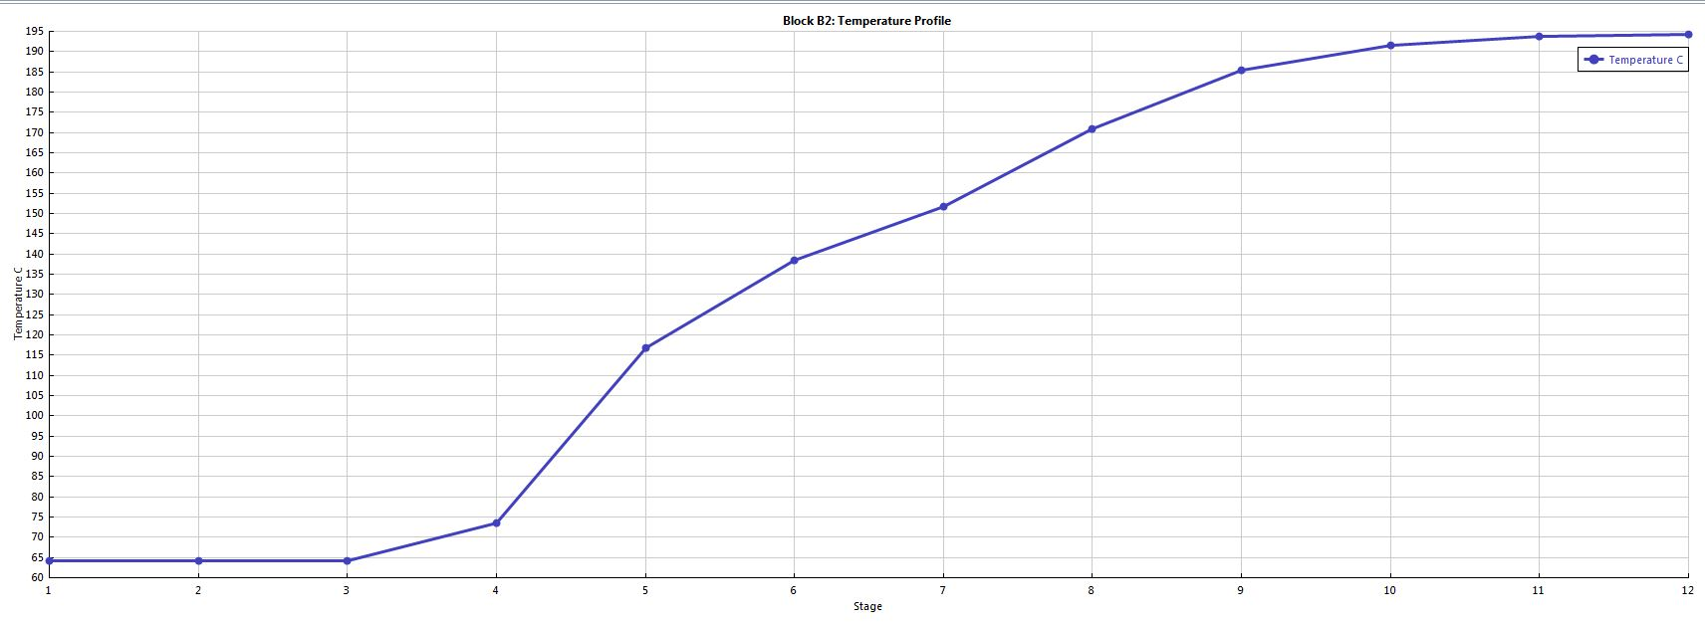

Column 2 composition profile

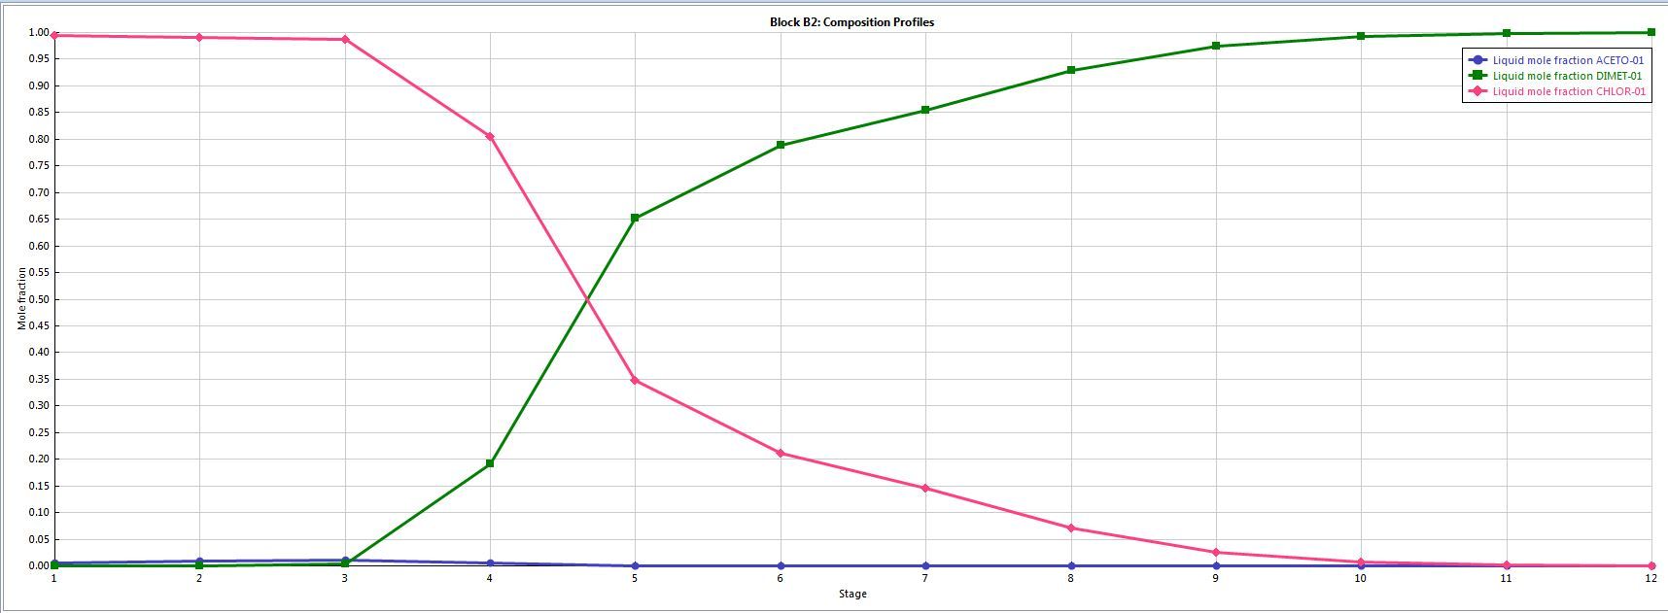

Heat duty of reboiler 249072.456 cal/sec

Heat duty of condenser -157884.743 cal/sec